Homestead Park Festival: Here is Hope

Access Pack Introduction

Set in the historic Homestead Park, Homestead Park Festival - Here is Hope - will take place over the first weekend of July, bringing artists, musicians, and changemakers to inspire, create, and share magical experiences

In this access pack you’ll find information about

Dates, times and location Page 2

Getting here Page 2

Details of terrain including wheelchair accessibility Page 3

Festival areas, including description and pictures Page 6

Deaf Access Page 18

Toilets Page 19

Quiet Area Page 21

First Aid, information, lost property Page 24
Dates, Times and Location

The festival will take place on Saturday 6th and Sunday 7th July.

It will be open from 10am - 8.30pm (Saturday) and 10am - 6pm (Sunday).

The main address is The Homestead, 40 Water End, York YO30 6WP however the accessible parking entrance is at Shipton Road, YO30 5RE.

Getting Here

By Car

Parking onsite will be limited to accessible parking only and will be for people with mobility requirements and blue badge holders.

If you have a blue badge you can just show it to the parking steward at the entrance.

If you think you need parking and don't have a blue badge please contact access@wildrumpus.co.uk so we can get your vehicle details on a list at the entrance

The entrance to the accessible car park will be at the Shipton Road entrance to the park, what three words is ///stored.august.shower

If you are a wheelchair user, assistance may be required as there are some uneven surfaces within the car park.

By Bus

The Ouse Lea is the closest bus stop, approximately 200m from the entrance. Buses 30, 30x, 31x, 74, 80, 825, 875, m31, all stop here. All buses are wheelchair accessible - see eastyorkshirebuses.co.uk for more details.

There is also a shuttle bus service that will run throughout the day between York Station and Homestead Park.
The exact location in York is at Memorial Gardens – Leeman Road.

What three words- torn.trim.traps

It will drop off by the YHA on Water End - which is approximately 100 metres walk to the park entrance.

What three words - mixed.others.forks

There will be two shuttle buses - one of them is unfortunately not wheelchair accessible. If you require wheelchair access you may need to wait up to 30 mins for the correct bus.

Our pedestrian entrances are on Water End, Shipton Road. The River Ouse path will be open for pedestrians and cyclists.

Wheelchair Accessibility and Details of Terrain

There is majority step free access across the site. The ground is a mixture of hardstanding paths, gravel and grass lawns. Although mostly level access, there are some sloped areas that some wheelchair users may find more difficult to navigate. In the event of wet weather some areas may become slippy or muddy which may impact wheelchair accessibility. Trackway will be placed across some grassed areas to improve access.

The Homestead Park Glasshouses will have temporary modifications for the festival to make them as accessible as possible. Below are some examples of the type of terrain to expect at the park. We will also provide a walkthrough video of the park, available on our website.
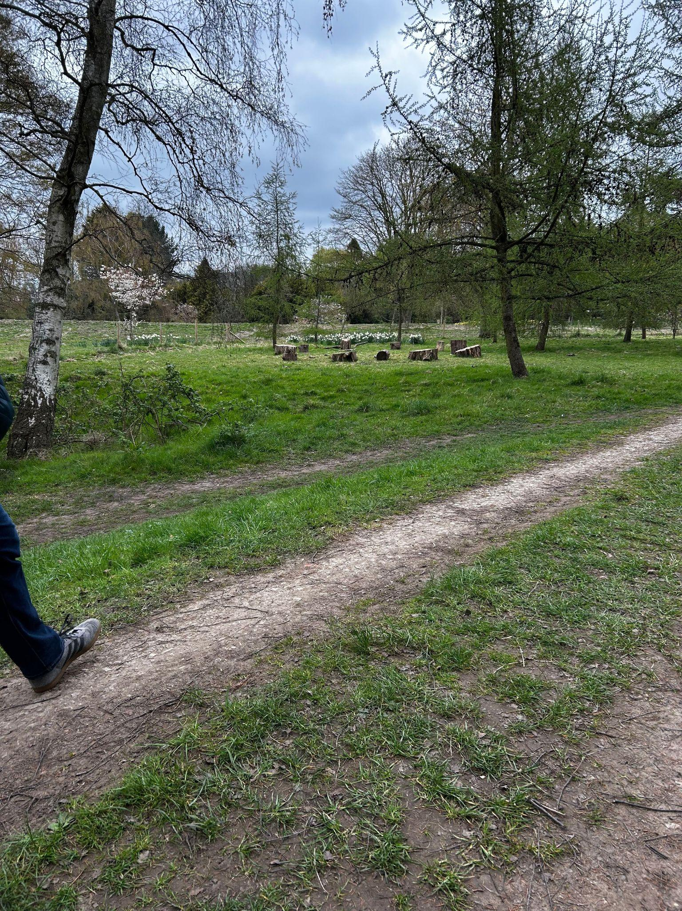
woodland pathway

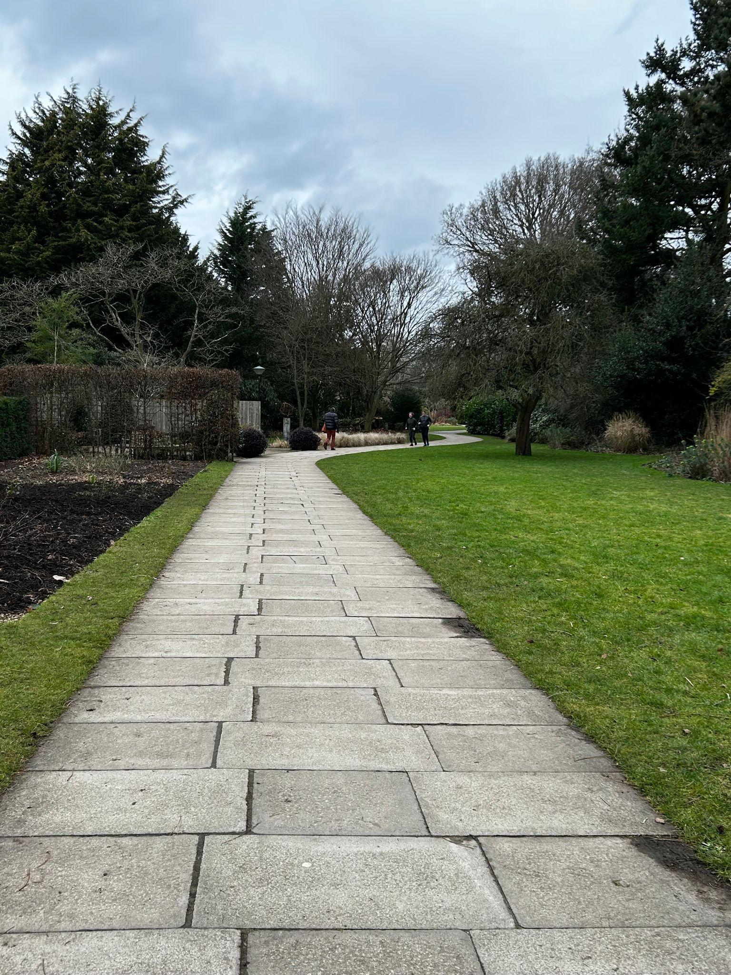
Paved pathway
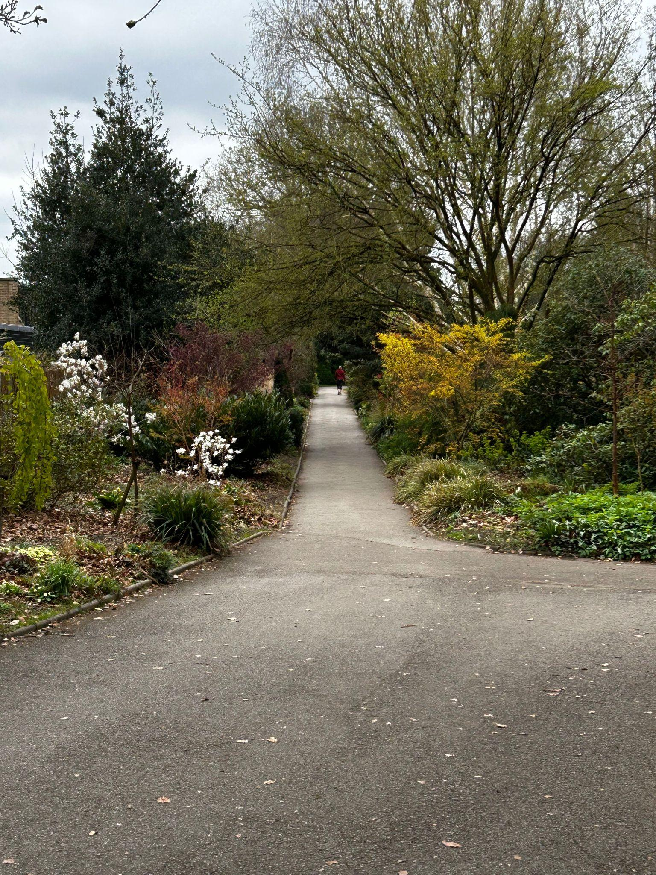
Tarmac pathway

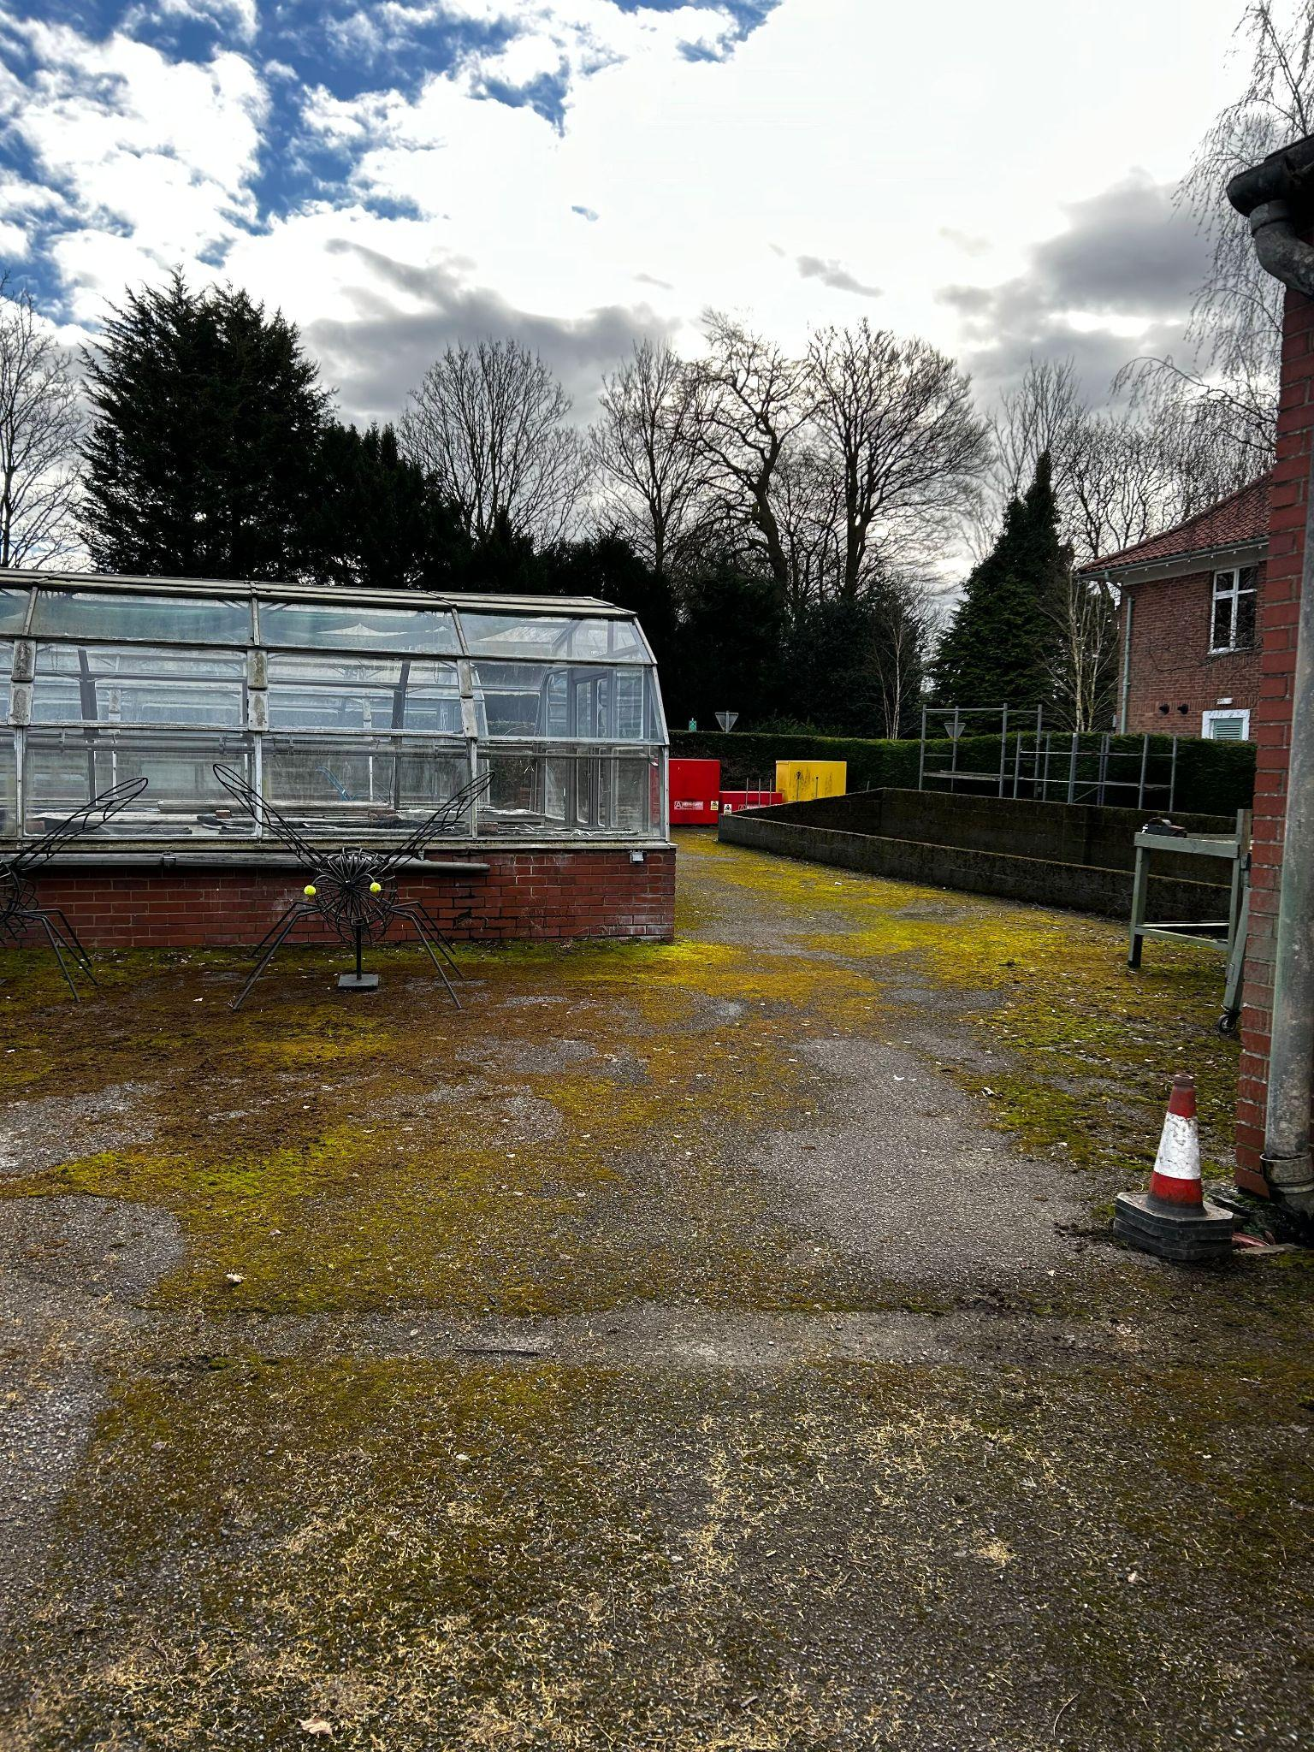
greenhouse area

Homestead Park Festival Areas

The accessible parking is at the Shipton Road Entrance, there is also pedestrian access for all through this area. There is an entrance on Water end, and an entrance for pedestrians and cyclists to enter from the River Ouse path on Clifton Ings.

Below is a map of the event.

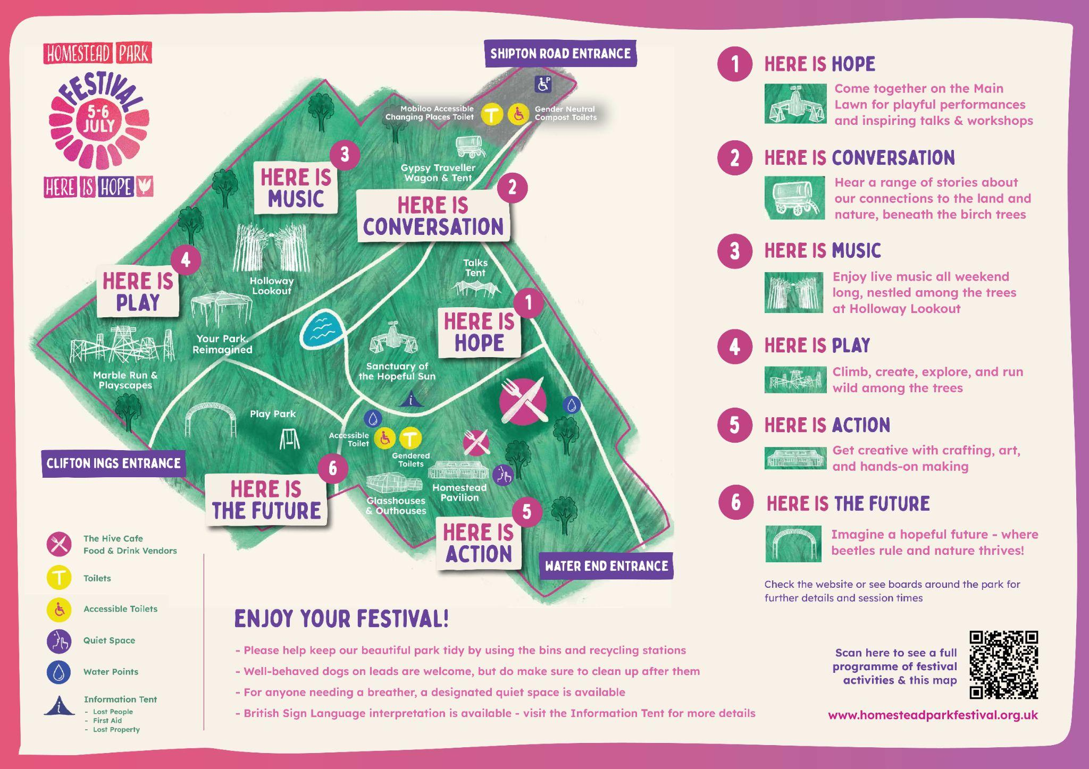
The festival Map

There is also signage around site to direct you.

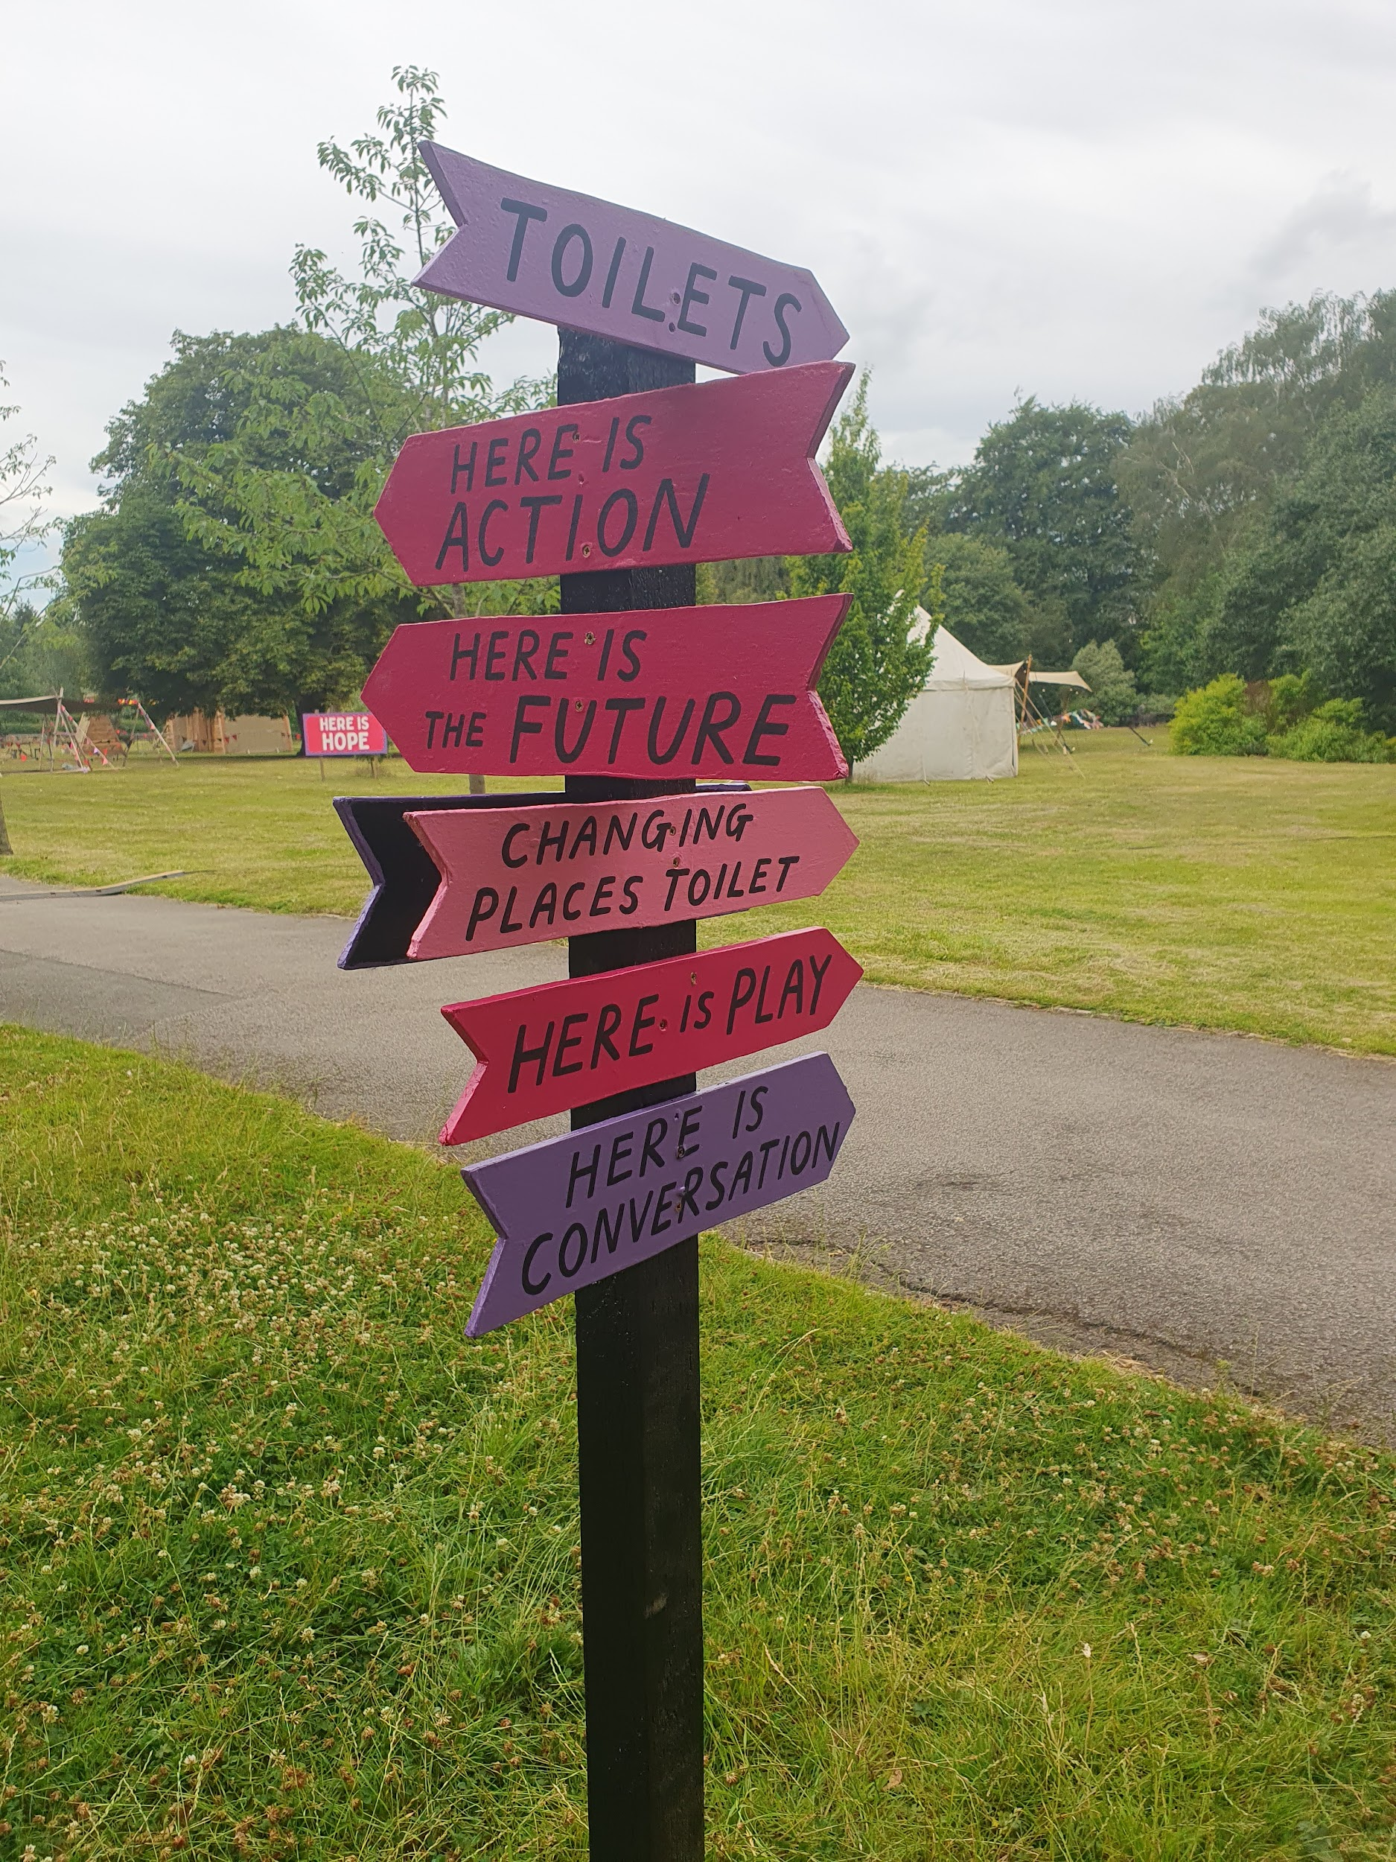
Signage to direct people around site

Here is Conversation

Here there will be conversations and story telling, from Roma and Traveller artists. There will be a Gypsy Traveller wagon and tent. There will be some seating in this area.

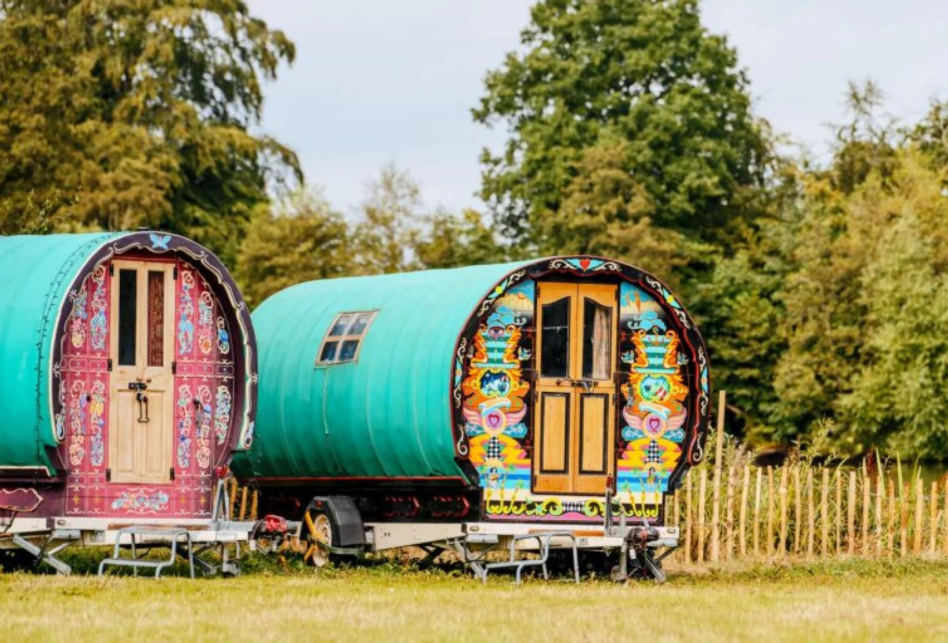
An image of colourfully decorated caravans

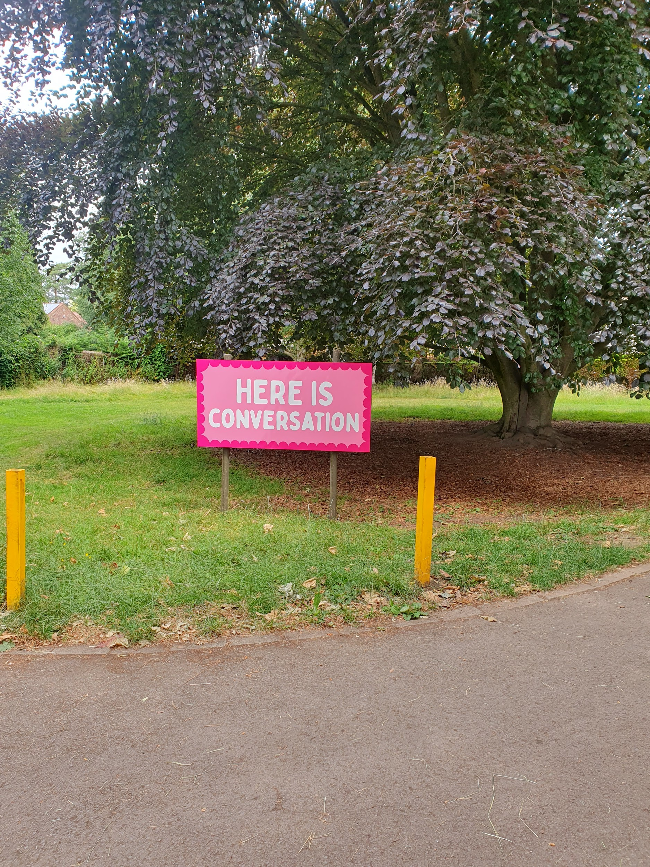
A large tree, under and around is the here is conversation area

Here is Hope

which is located on the main lawn and is where performances and talks will take place. The two main structures here will be Sanctuary of the Hopeful Sun which has workshops in and a stretch tent which will have the talks programme in. The seating in this area will be benches. Some folding wooden chairs will also be available if a back is required.

Other workshops will be on the main lawn plus an information tent and food and drink vendors.

There are park benches, some picnic benches and other festival tables and benches on the main lawn. Stewards provide some seating with backs - please ask!

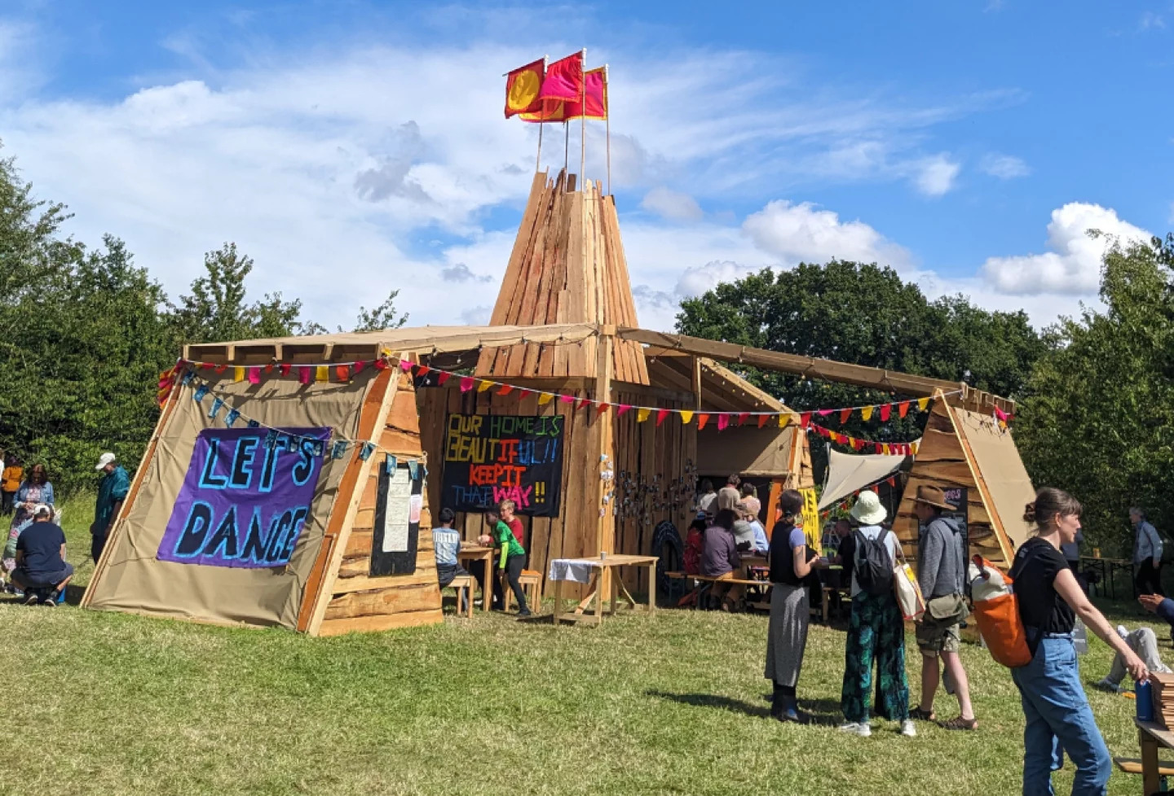
Sanctuary of the Hopeful Sun structure

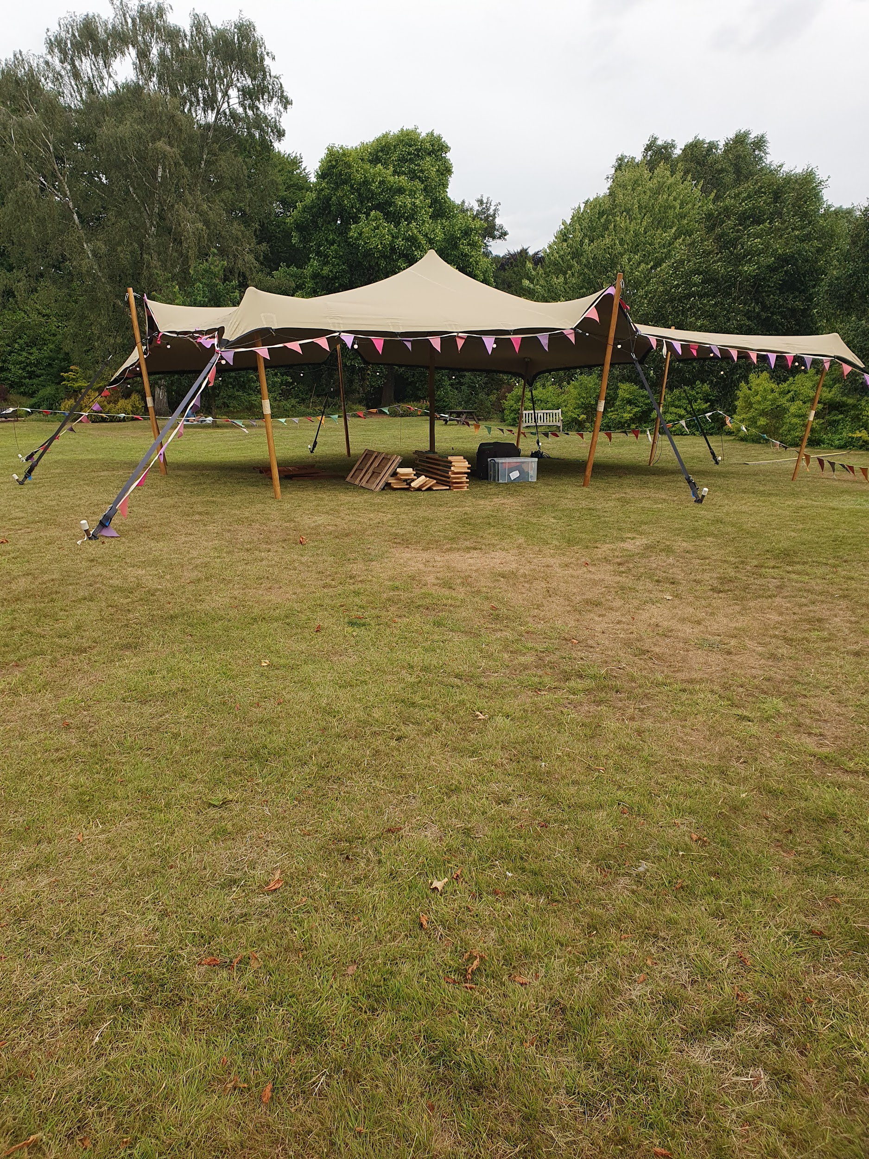
The Stretch tent

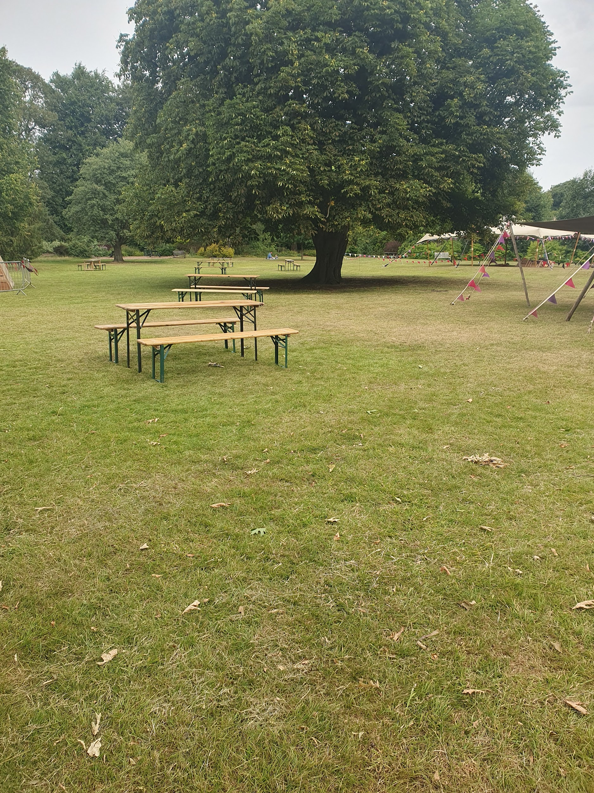
Example of bench seating.

Here is Music

There will be musicians playing here. This area may become busy and noisy.

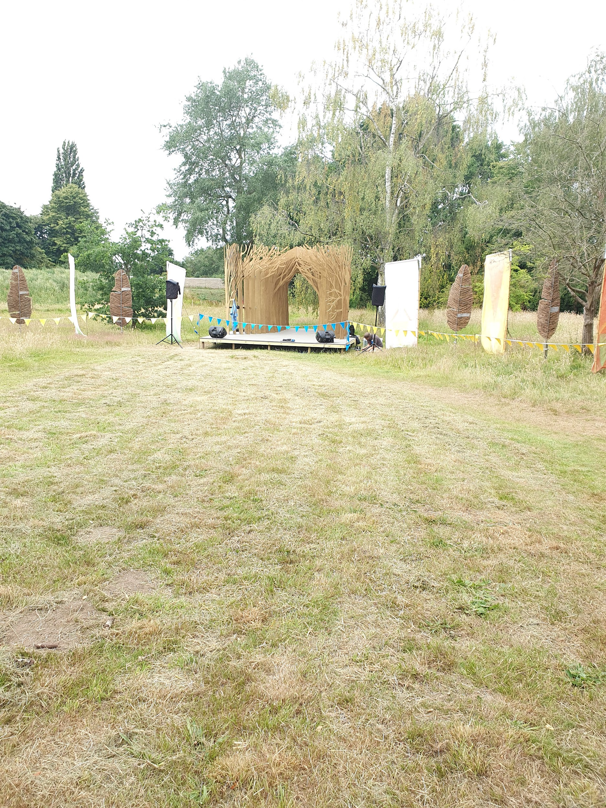
A grassed field with a small stage area

Festival goers will sit on the ground on a slope in this area to view and hear the music. Some wheelchair users may have some difficulty navigating down the slope but a viewing area has been created at the top of the slope that can be accessed by wheelchair users. Stewards can also provide seating if needed - please do ask!

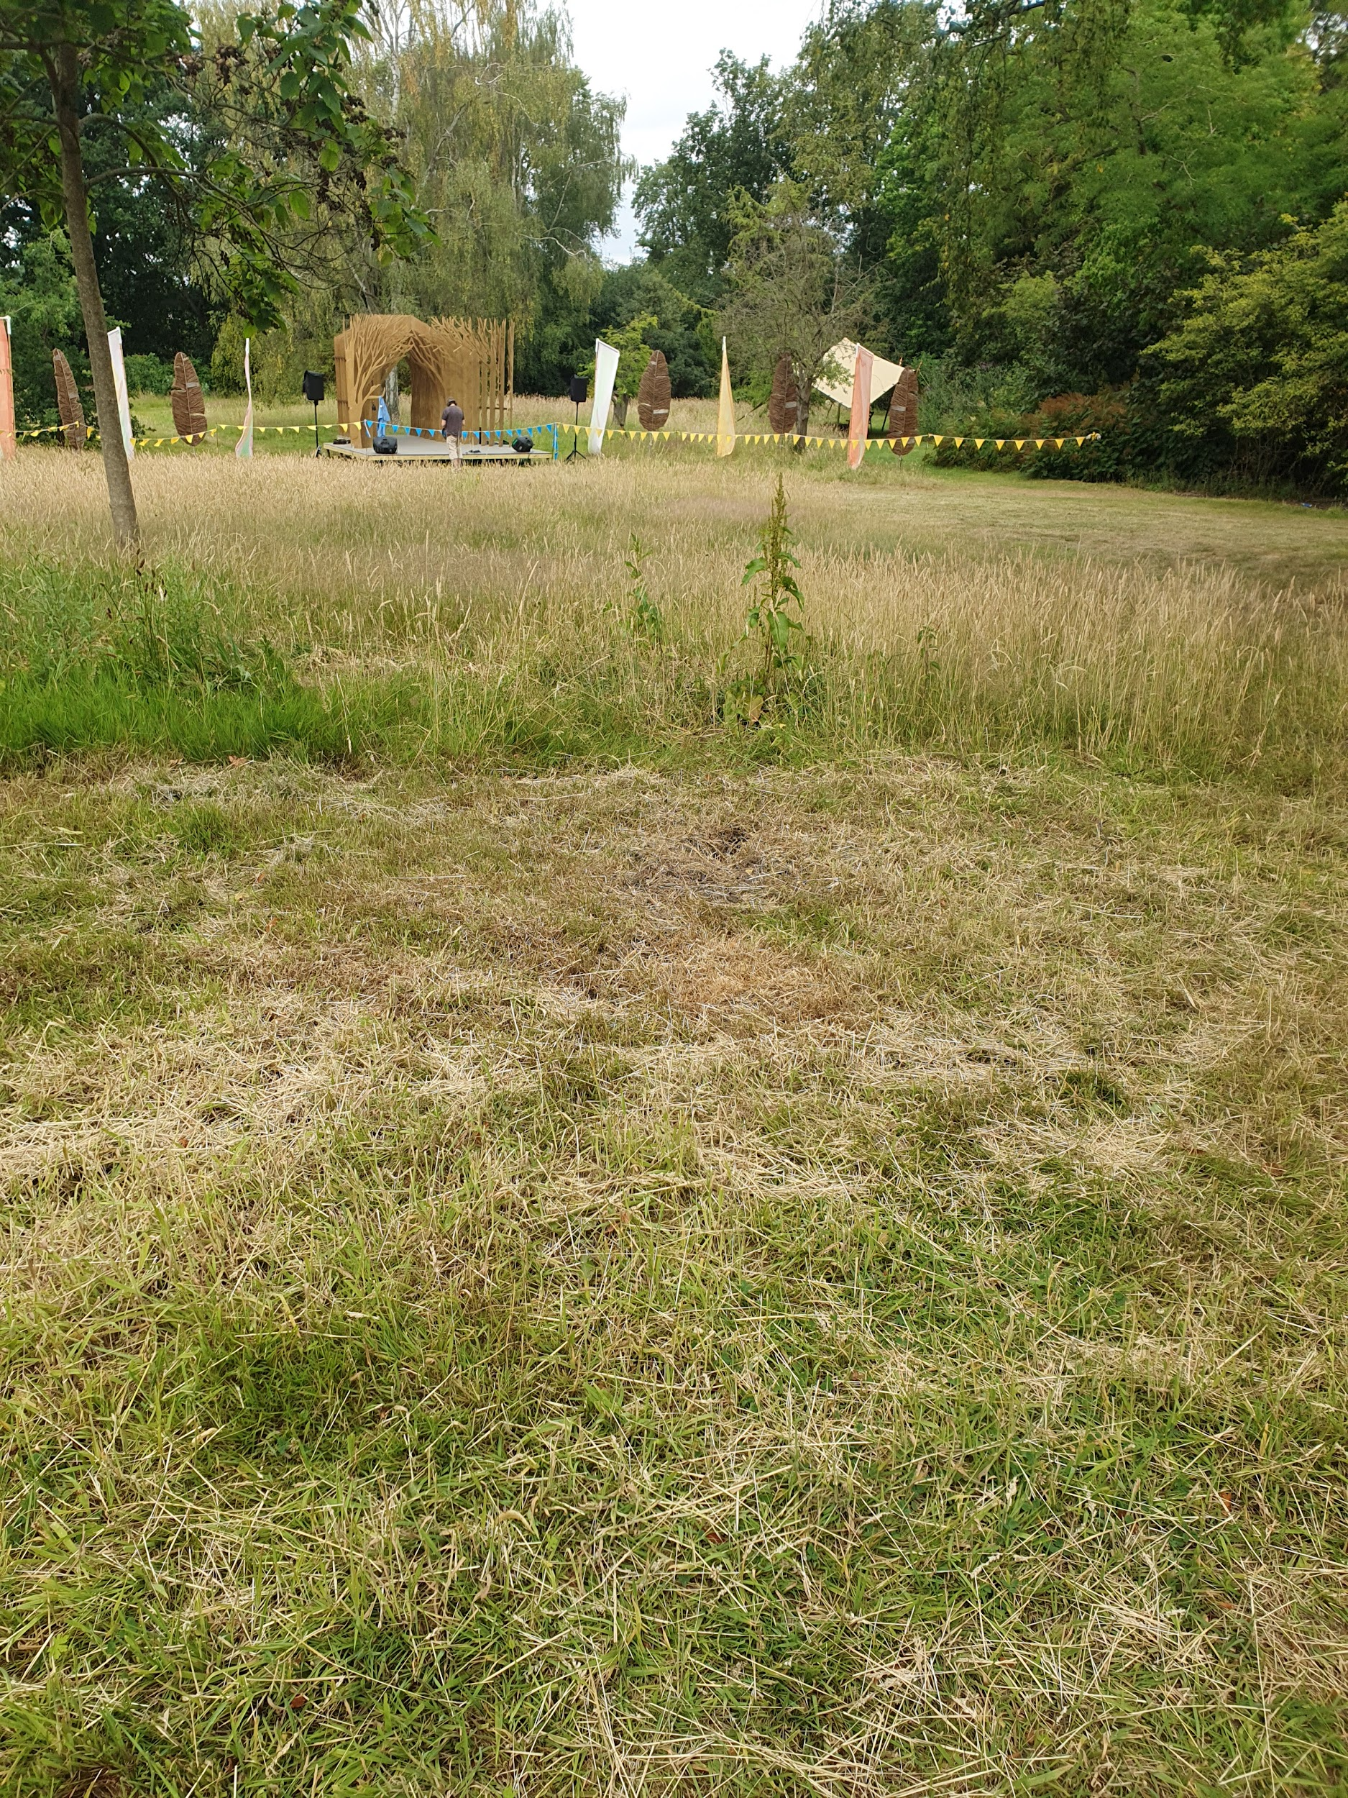
Location and view of the accessible viewing area

Here is Play

Is where the giant marble run and Playscapes is located. This is set in a woodland area, with twigs and roots on the ground surface. This area may be less accessible for wheelchair users.
At the top of the woodland is a new pop up structure which may in time become more permanent. You can visit here to give your thoughts on what you would like from a new structure or from Homestead Park in the future.

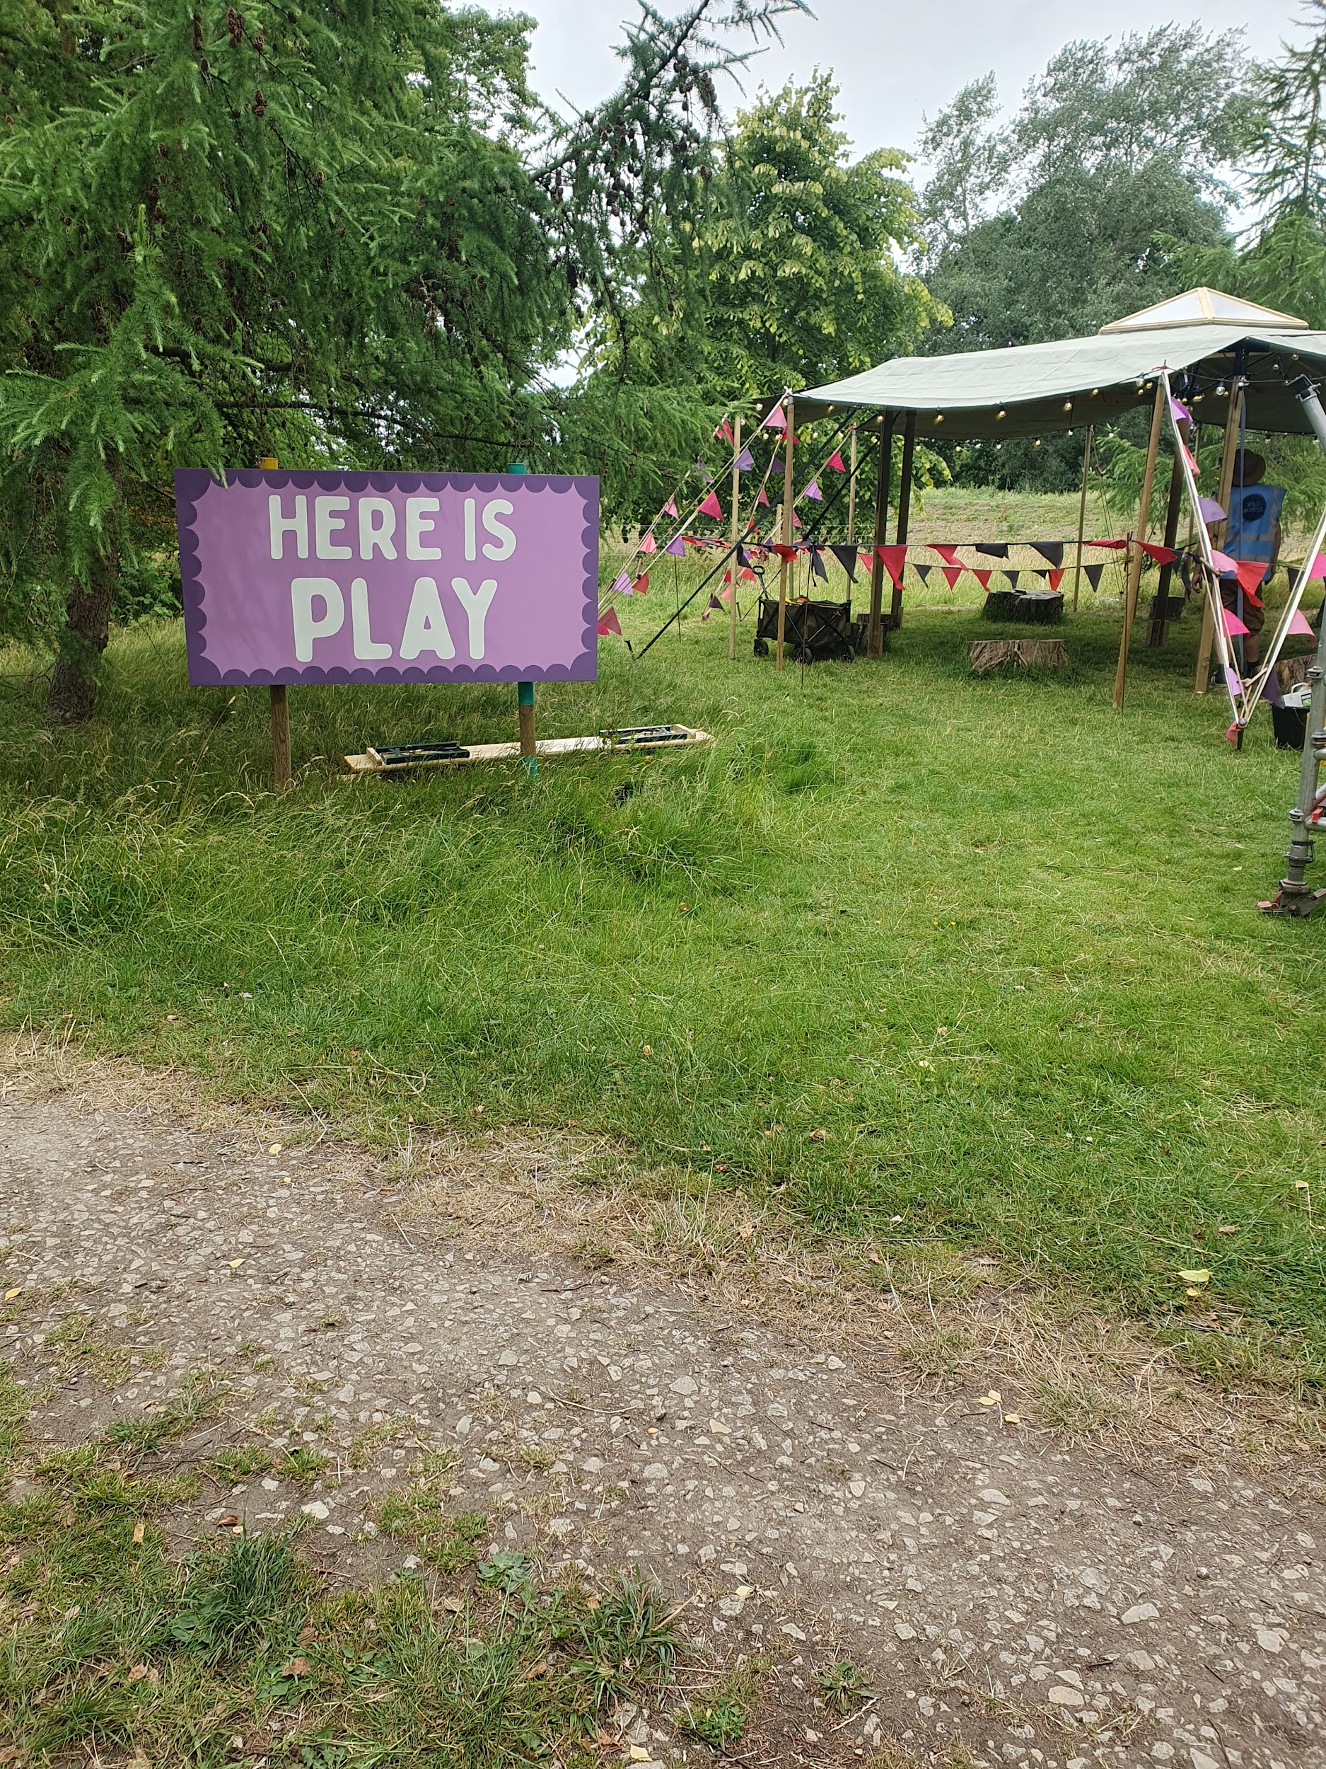
The pop up structure

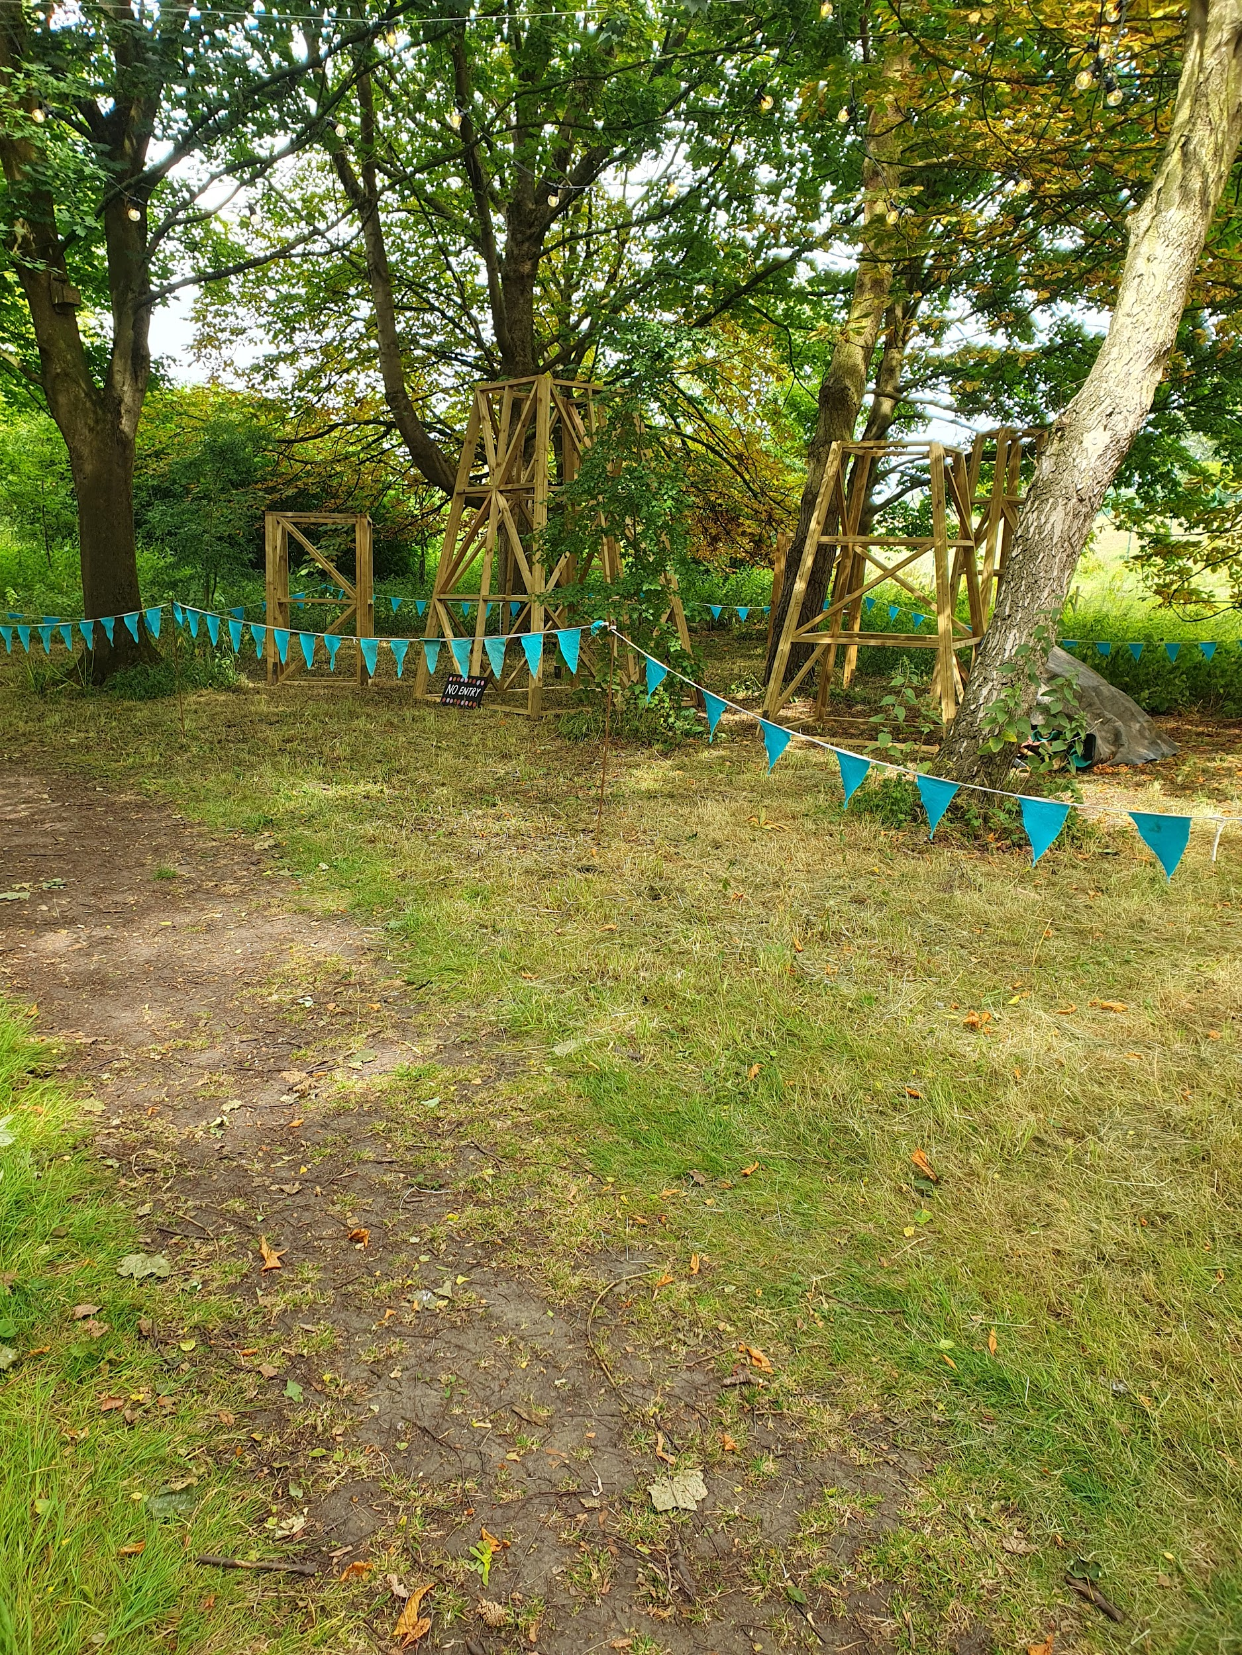
The location of the Giant Marble Run

Here is the Future

Here is the childrens play area in the park with swings, roundabouts, slides and climbing frames.

At the bottom of the area a colourful art installation Sign of the Times will grow over the weekend and storytellers from the future will be sharing their stories of York and what it may be like in 2125. The route is over grass and has some ruts and bumps.

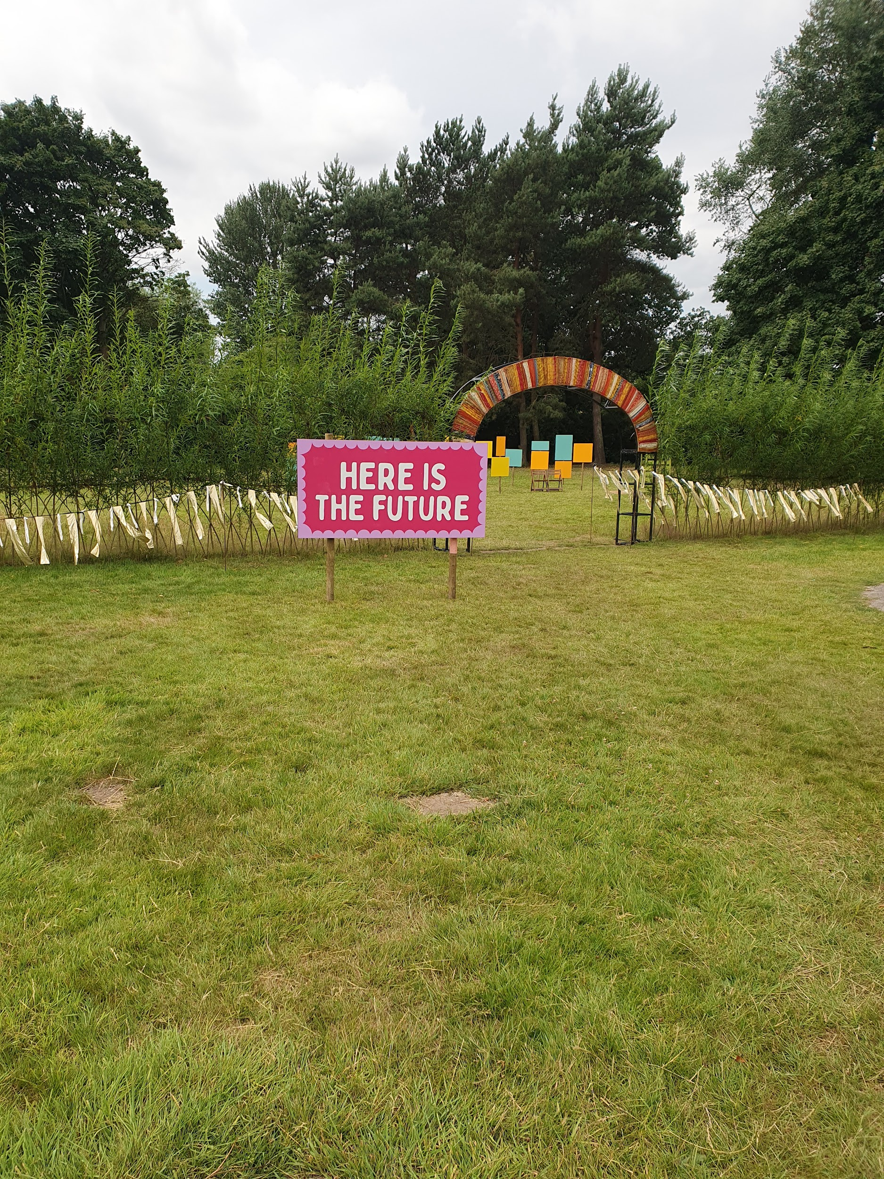
The Sign of the times installation, beyond the ‘Here is The Future’ Sign

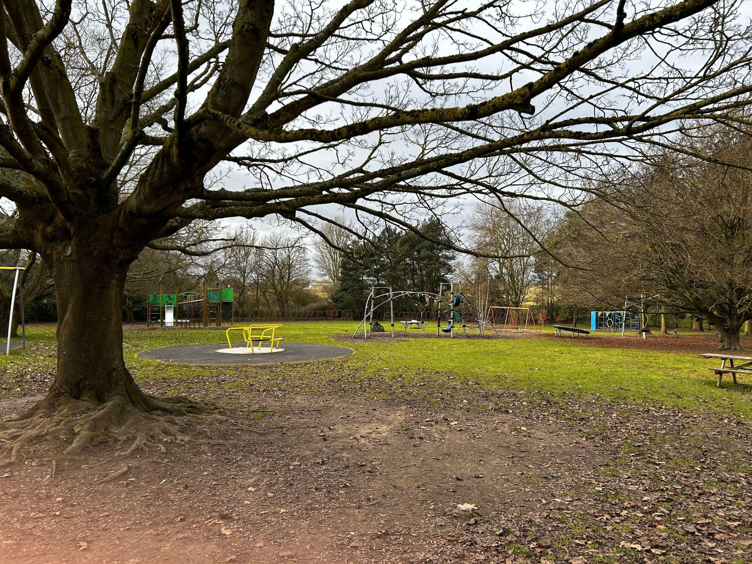
The children’s play area

Here is Action

is located in the glasshouses and Homestead Pavilion. There will be a variety of crafting and making activities and workshops here. Activities are both indoors and outdoors and most activities will be wheelchair friendly however whilst the old greenhouses have been adapted to be more accessible they may not be fully accessible to all. Wheelchair accessible toilets are available here, as well as standard gendered toilets.

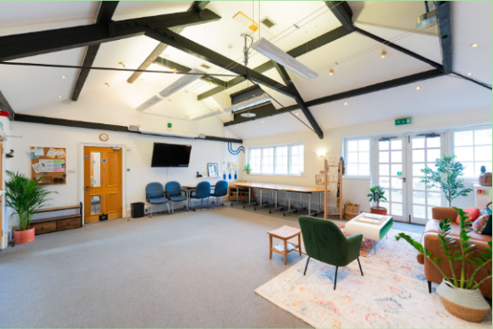
Inside the pavilion building

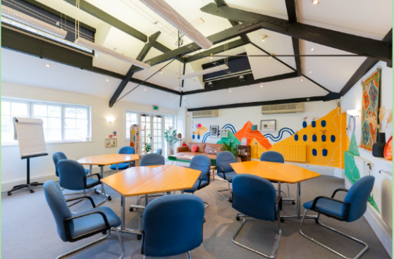
Inside the pavilion with tables and chairs arranged

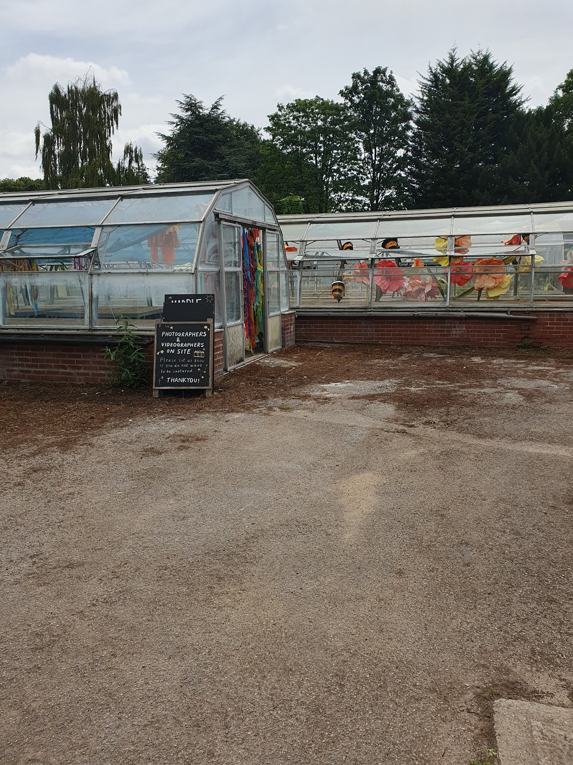
The glasshouses and glasshouse area

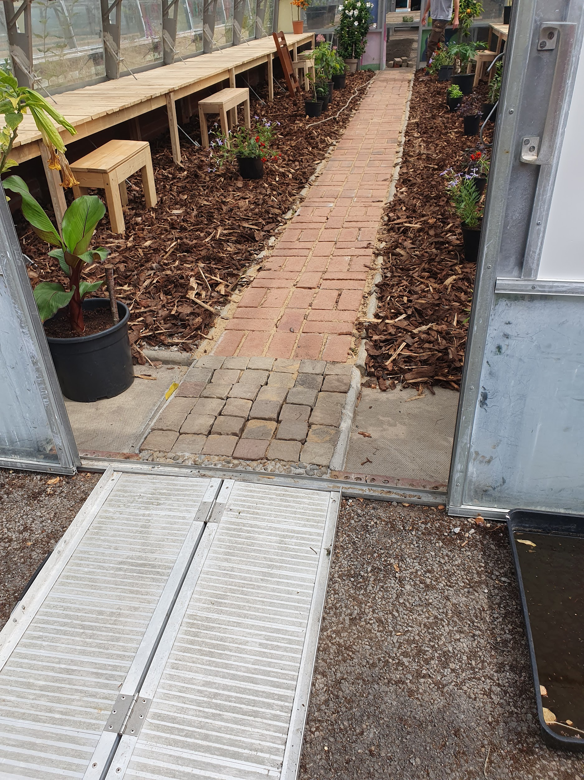
Entrance to one of the glasshouses. There is a small ramp over the lip.

You can find a walk through video of the site below.

Deaf access

BSL interpreters will be onsite throughout the festival. The speaker programme will have an interpreter at each session and interpreters will also be available for workshops and other activities.

Please contact us at access@wildrumpus.org.uk if you’d like to use this service or visit the Information Tent in the park.

TRUTH! by Ramshacklicious and Hijinx features little spoken language and is a visual based performance.

The Wild Beasts of Silly are a visual based walkabout act, as are the Ravens.

Toilets

Toilet locations are marked on our map.

There will be gender neutral toilets at the Shipton Park Entrance. These will be compost toilets.

There will also be a mobiloo here. A mobiloo is a mobile changing places toilet with an adult sized changing bed, hoist, accessible toilet and a friendly attendant. To find more out about mobiloo’s visit their website https://mobiloo.org.uk/

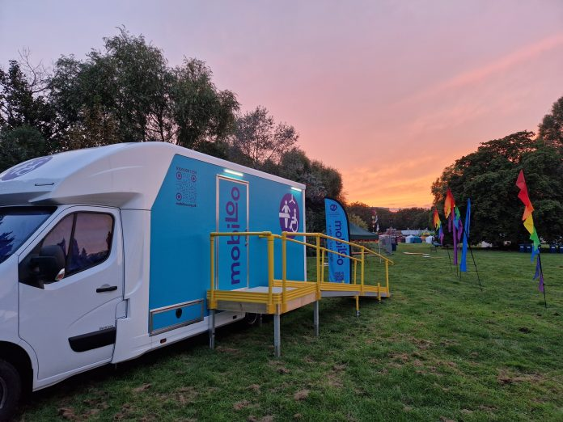
A moblioo in a field at sunset. It looks like a large blue van with a door on the side, a ramp leading to it.

There are gendered standard toilets available at the park toilet block. Also located here is one accessible toilet which you can see in this video. There is a 5cm lip before the ramp to this toilet.
A radar key is not required.

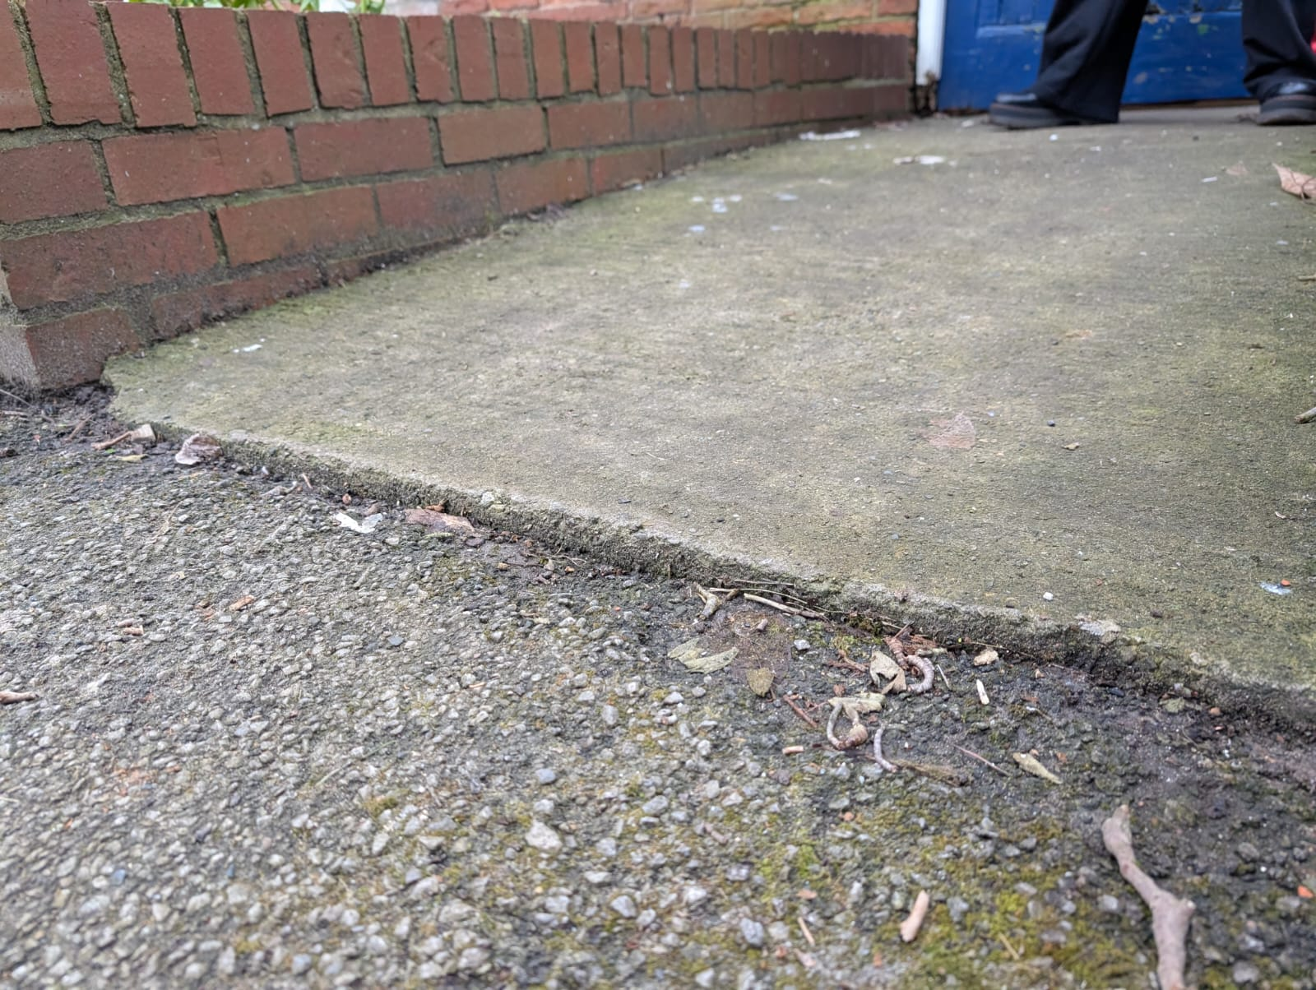
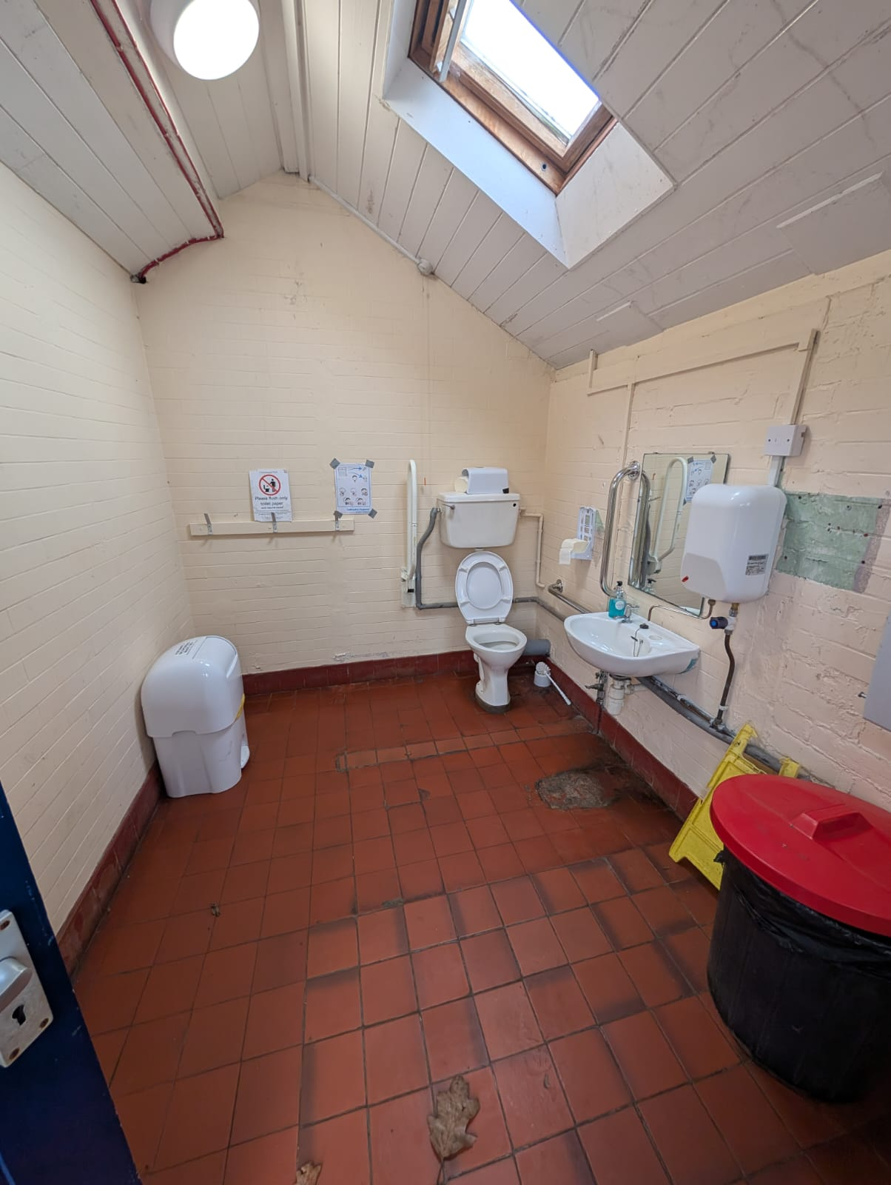
Pictures of the access toilet, and the small lip to the ramp.

The Pavilion has two accessible toilets which you can see in this video.

Assistance and Guide Dogs

Assistance and guide dogs are more than welcome at Homestead Park Festival. Pet dogs are also welcome, but they must stay on lead.

Quiet Area

We will have a quiet area available for those who need to take a moment away from the festival. This is located in the Pavilion and marked on our map. You are welcome to ask any of the stewards to direct you to this.

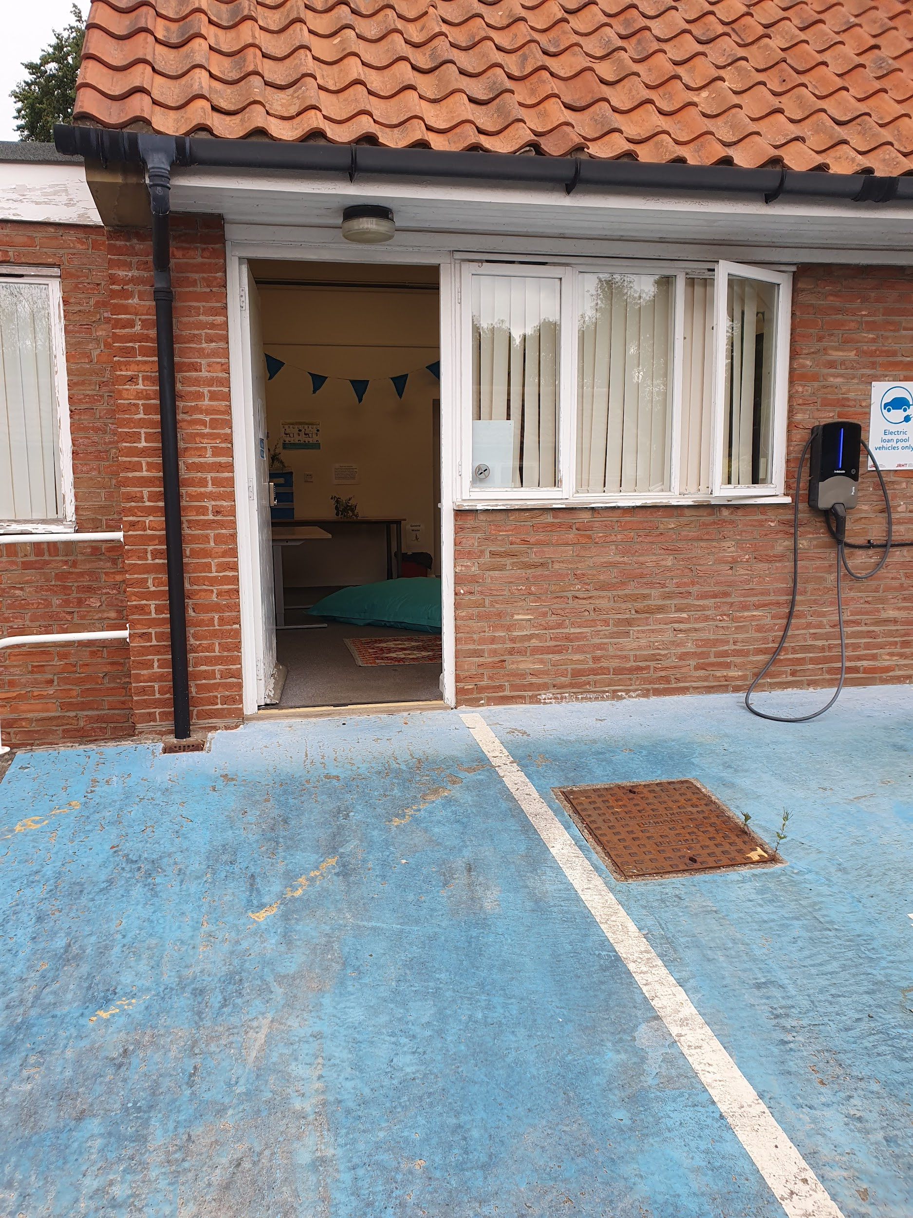
Entrance to the quiet area

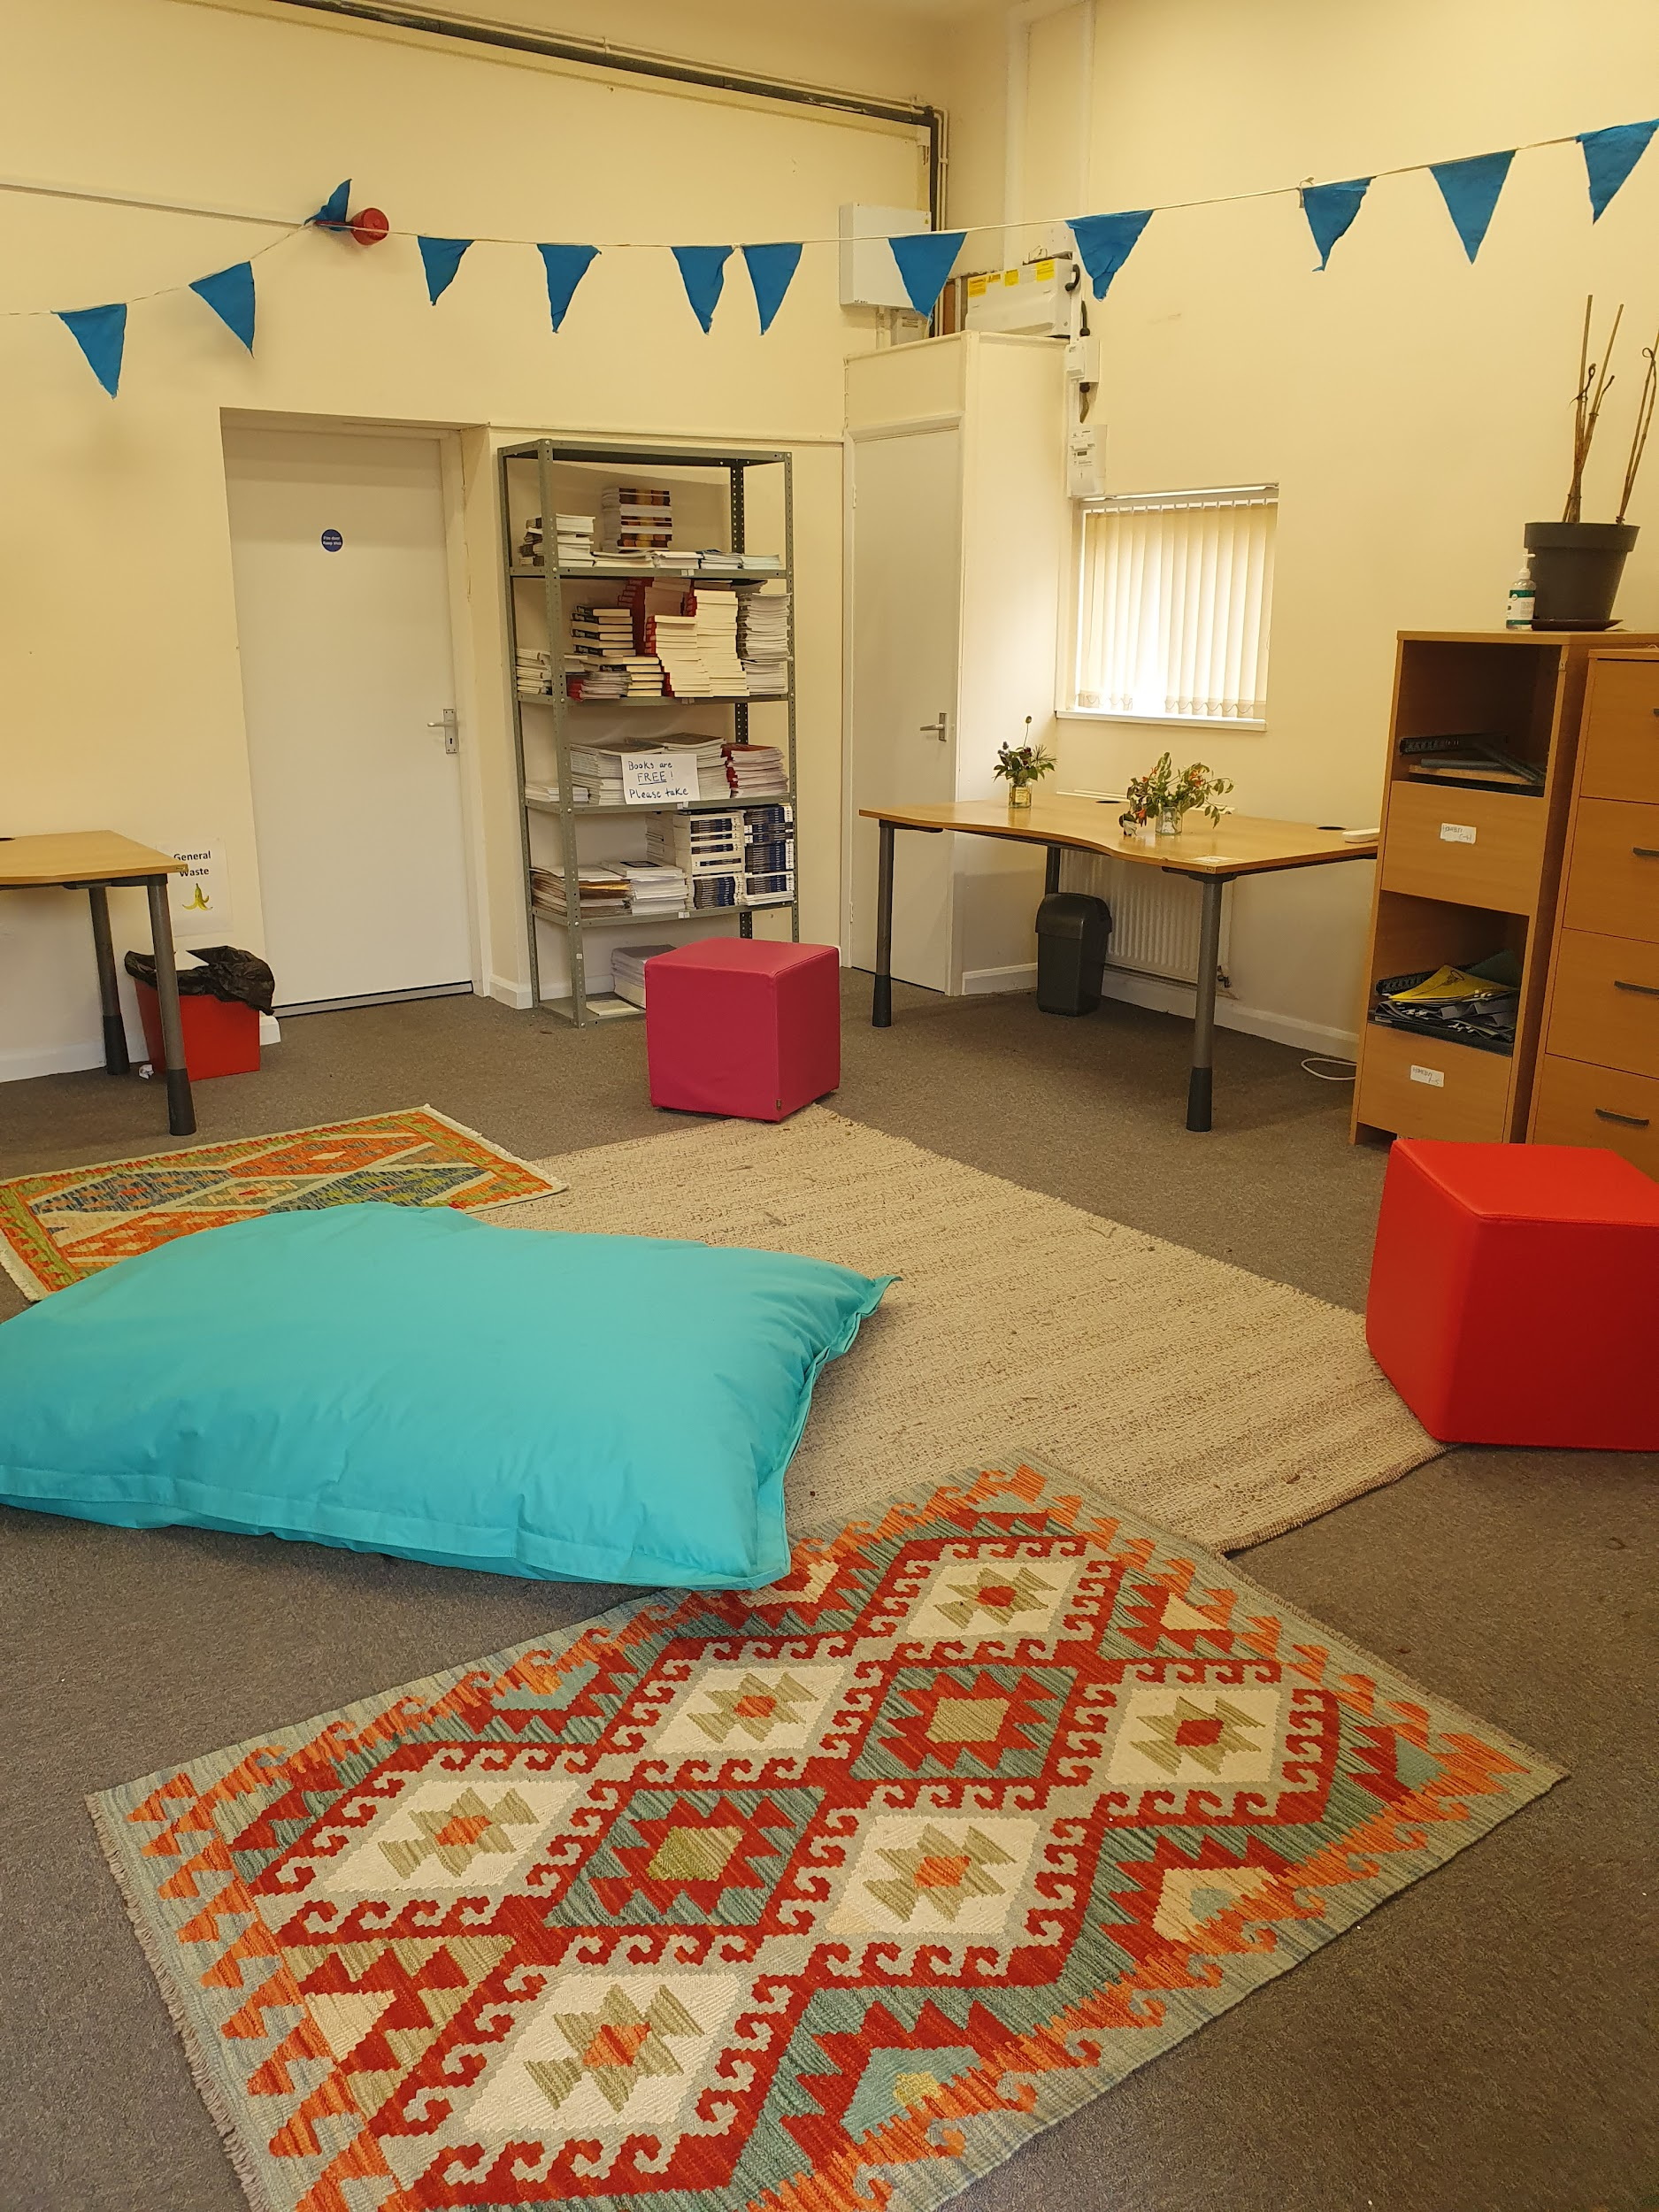
Inside the quiet area

First Aid, Information and Lost Property

There will be first aiders available on site, they will be located at the information tent. This is also where you will find lost property and our Info point.

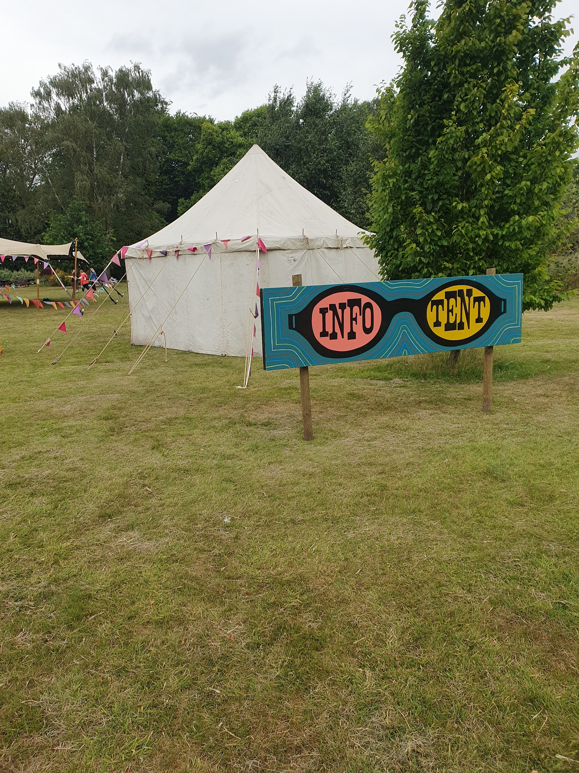
A white tent in a park - a sign with glasses on - in each eye it spells “info point”

